Task 1   
F & R 10 SEC  
// Motor A connections

int enA = 9;

int in1 = 8;

int in2 = 7;

// Motor B connections

int enB = 3;

int in3 = 5;

int in4 = 4;

void setup()

{

  // Set all the motor control pins to outputs

  pinMode(enA, OUTPUT);

  pinMode(enB, OUTPUT);

  pinMode(in1, OUTPUT);

  pinMode(in2, OUTPUT);

  pinMode(in3, OUTPUT);

  pinMode(in4, OUTPUT);

  // Turn off motors - Initial state

  digitalWrite(in1, LOW);

  digitalWrite(in2, LOW);

  digitalWrite(in3, LOW);

  digitalWrite(in4, LOW);

}

void loop()

{

  directionControl();

  delay(1000); // Pause before repeating the cycle

}

void directionControl()

{

  // Set motors to maximum speed

  analogWrite(enA, 255);

  analogWrite(enB, 255);

  // Move forward for 10 seconds

  digitalWrite(in1, HIGH);

  digitalWrite(in2, LOW);

  digitalWrite(in3, LOW);

  digitalWrite(in4, HIGH);

  delay(10000);

  // Stop for 3 seconds

  digitalWrite(in1, LOW);

  digitalWrite(in2, LOW);

  digitalWrite(in3, LOW);

  digitalWrite(in4, LOW);

  delay(3000);

  // Move in reverse for 10 seconds

  digitalWrite(in1, LOW);

  digitalWrite(in2, HIGH);

  digitalWrite(in3, HIGH);

  digitalWrite(in4, LOW);

  delay(10000);

  // Stop the motors again

  digitalWrite(in1, LOW);

  digitalWrite(in2, LOW);

  digitalWrite(in3, LOW);

  digitalWrite(in4, LOW);

}

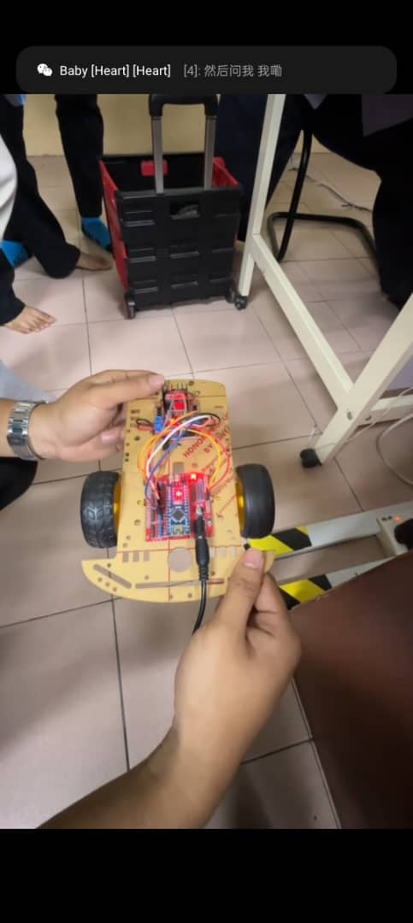

LEFT RIGHT 10 SEC

// Motor A connections

int enA = 9;

int in1 = 8;

int in2 = 7;

// Motor B connections

int enB = 3;

int in3 = 5;

int in4 = 4;

void setup()

{

  // Set all the motor control pins to outputs

  pinMode(enA, OUTPUT);

  pinMode(enB, OUTPUT);

  pinMode(in1, OUTPUT);

  pinMode(in2, OUTPUT);

  pinMode(in3, OUTPUT);

  pinMode(in4, OUTPUT);

  // Turn off motors - Initial state

  digitalWrite(in1, LOW);

  digitalWrite(in2, LOW);

  digitalWrite(in3, LOW);

  digitalWrite(in4, LOW);

}

void loop()

{

  directionControl();

  delay(1000); // Pause before repeating the cycle

}

void directionControl()

{

  // Set motors to maximum speed

  analogWrite(enA, 255);

  analogWrite(enB, 255);

  // Move left forward for 10 seconds

  digitalWrite(in1, HIGH); // Motor A forward

  digitalWrite(in2, LOW);

  delay(10000);

  // Stop for 3 seconds

  digitalWrite(in1, LOW);

  digitalWrite(in2, LOW);

  digitalWrite(in3, LOW);

  digitalWrite(in4, LOW);

  delay(3000);

  // Move right forward for 10 seconds

  digitalWrite(in3, LOW); // Motor B forward

  digitalWrite(in4, HIGH);

  delay(10000);

  // Stop the motors again

  digitalWrite(in1, LOW);

  digitalWrite(in2, LOW);

  digitalWrite(in3, LOW);

  digitalWrite(in4, LOW);

}

PART B

SERVO MOTOR 90

#include <Servo.h>

Servo myservo; // create servo object to control a servo

// twelve servo objects can be created on most boards

int pos = 0; // variable to store the servo position

void setup() {

myservo.attach(9); // attaches the servo on pin 9 to the servo object

}

void loop() {

 for (pos = 0; pos <= 90; pos += 1) { // goes from 0 degrees to 180 degrees

 // in steps of 1 degree

myservo.write(pos); // tell servo to go to position in variable 'pos'

delay(15); // waits 15ms for the servo to reach the position

 }

for (pos = 90; pos >= 0; pos -= 1) { // goes from 180 degrees to 0 degrees

myservo.write(pos); // tell servo to go to position in variable 'pos'

delay(15); // waits 15ms for the servo to reach the position

 }

}

